How to Register for Pickleball Online
Step 1: Go to https://falmouthma.myrec.com/info/default.aspx
→If you have an account- Click Log In
If you do not have an account- Click New Account
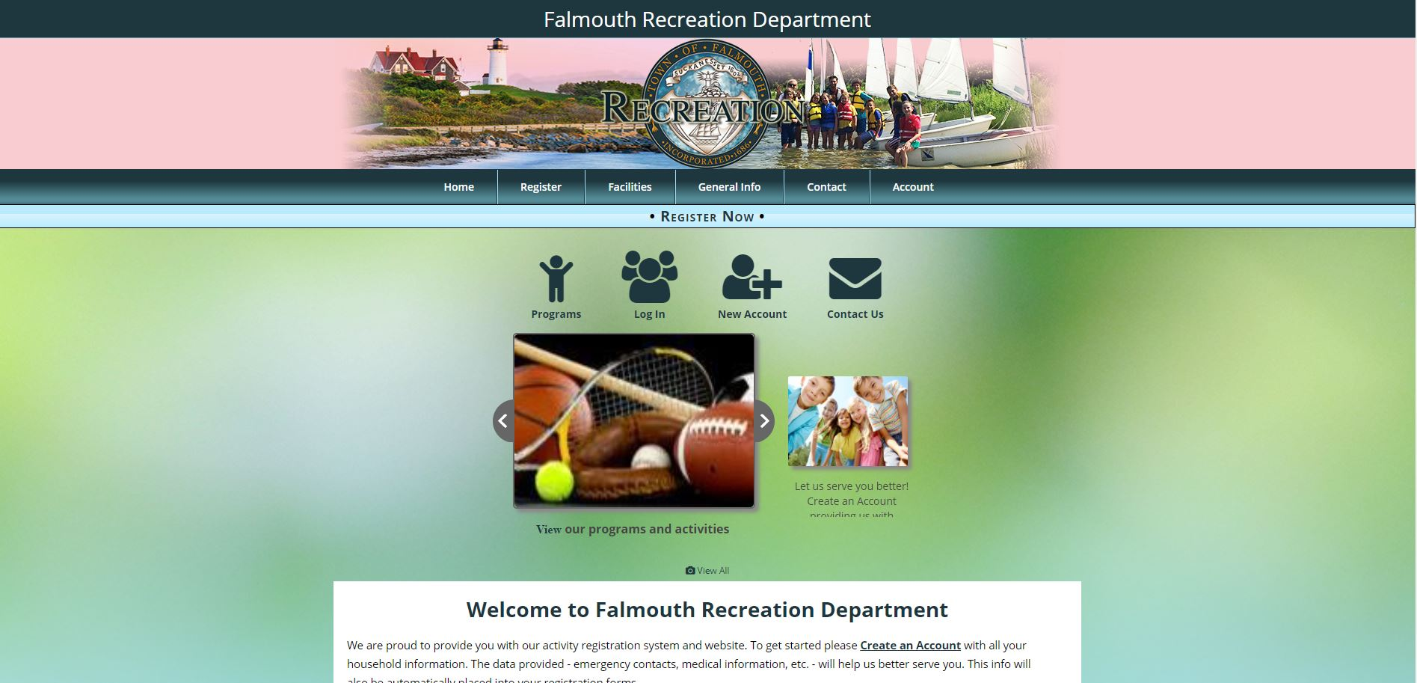
Step 2: After logging in - Click Programs
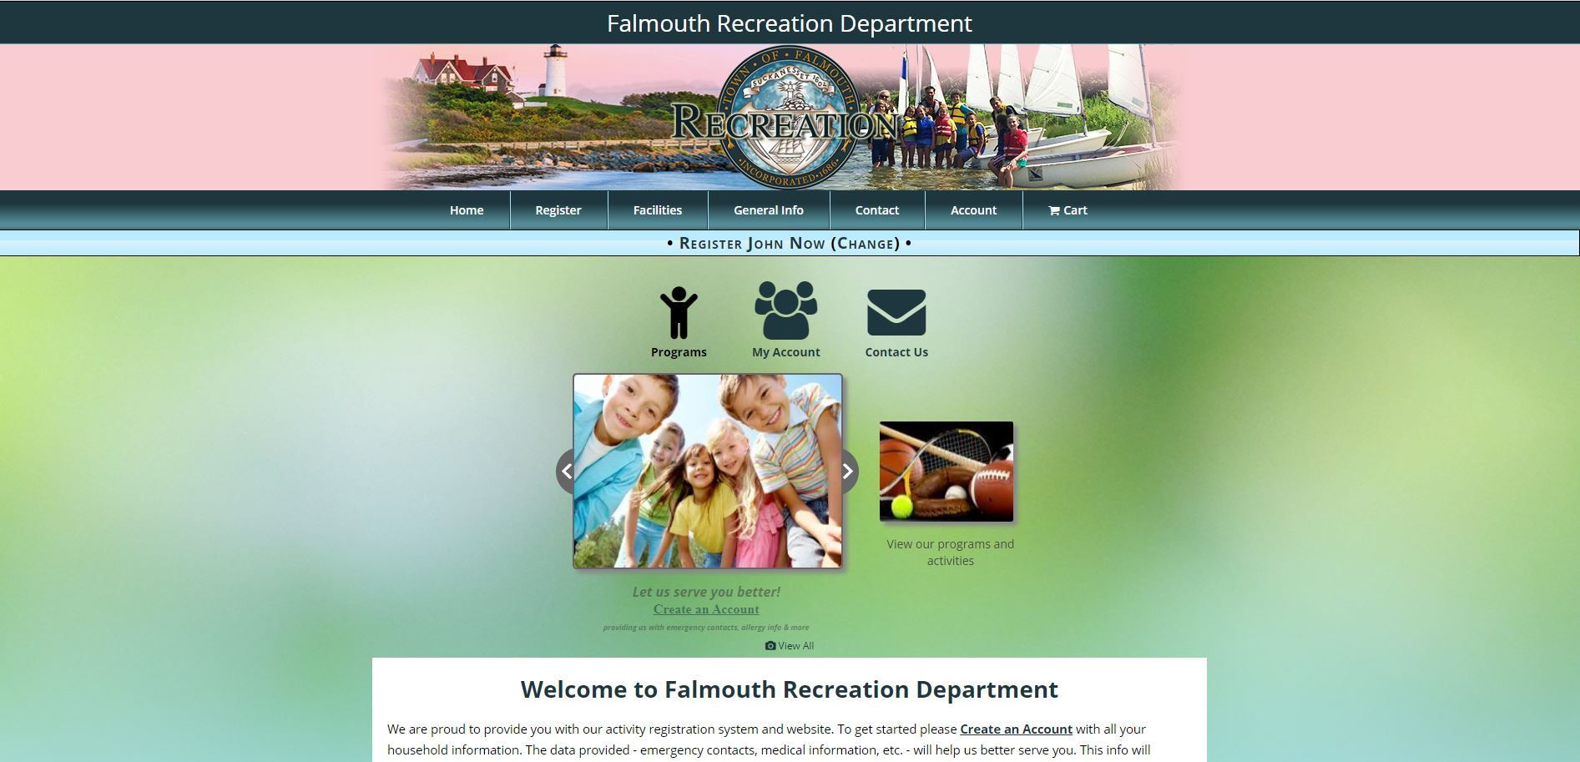

Step 3: Click Pickleball
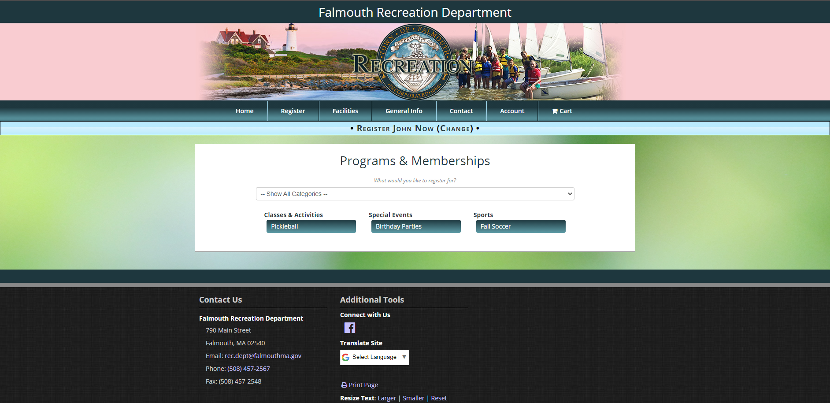
Step 4: Click on Register (Your Name) next to the level you wish to register for.
If your name is not displayed next to Register- Click Change member and click your name.
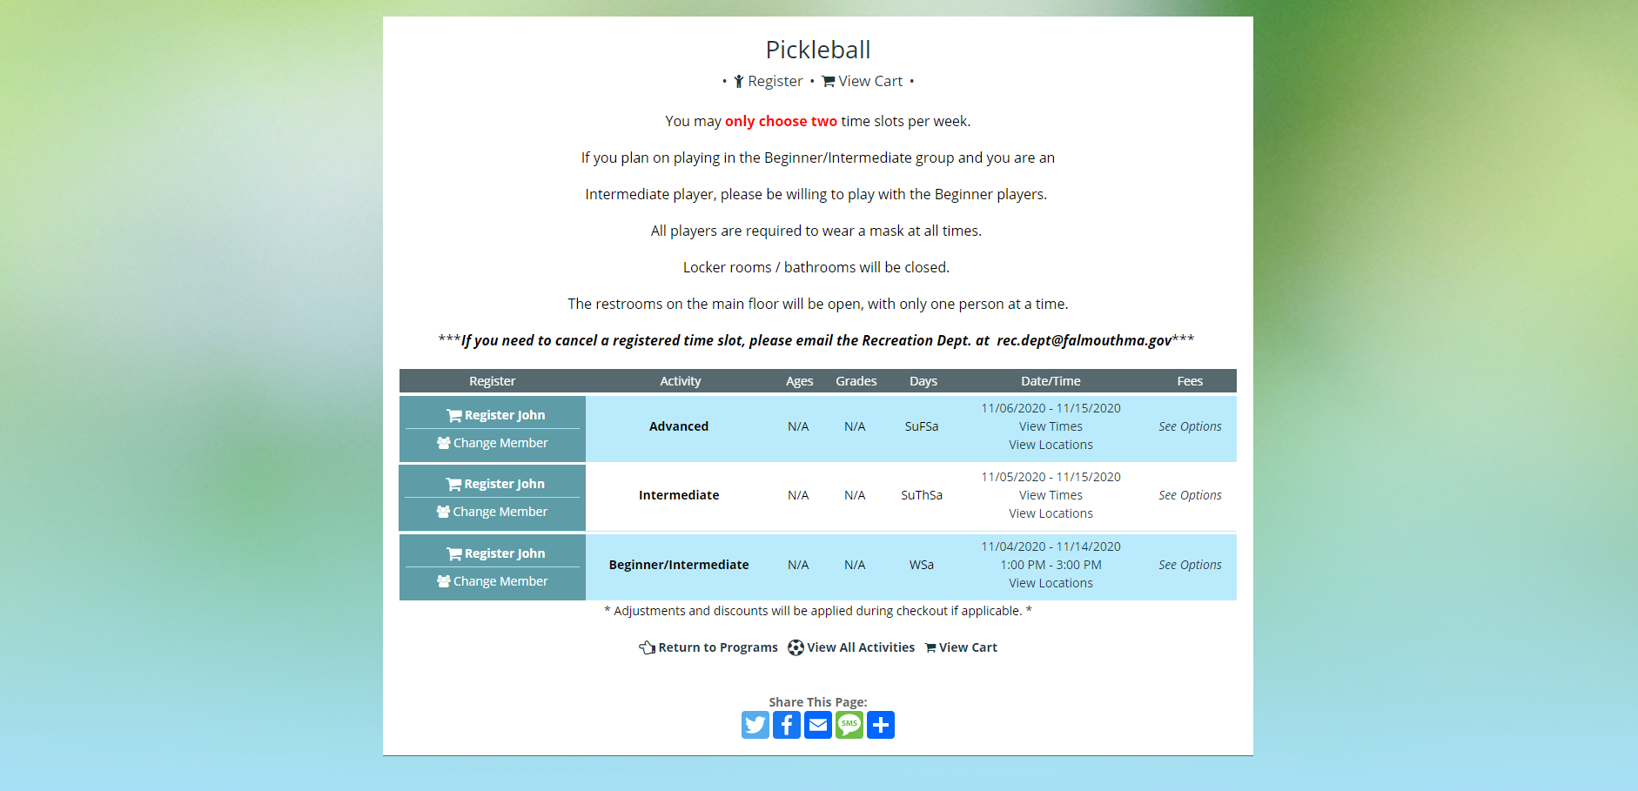

Step: 5 Click Choose Options to select date and time
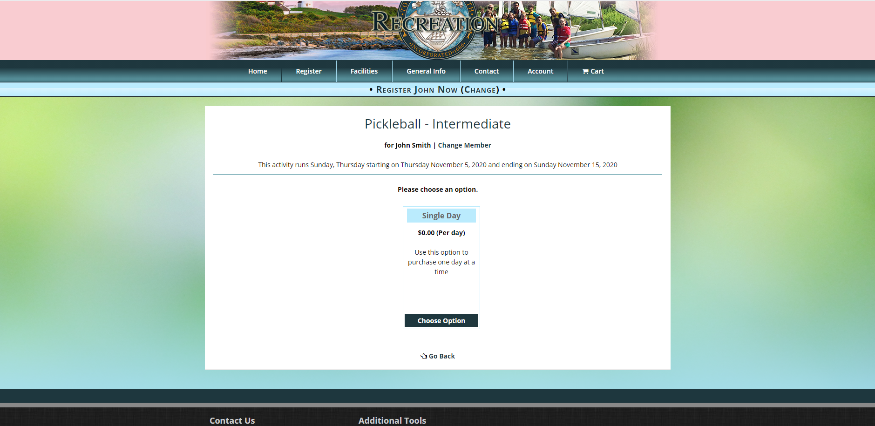
Step 6: Click the drop-down menu to select your time and then check off date/dates to play and click Add Selected
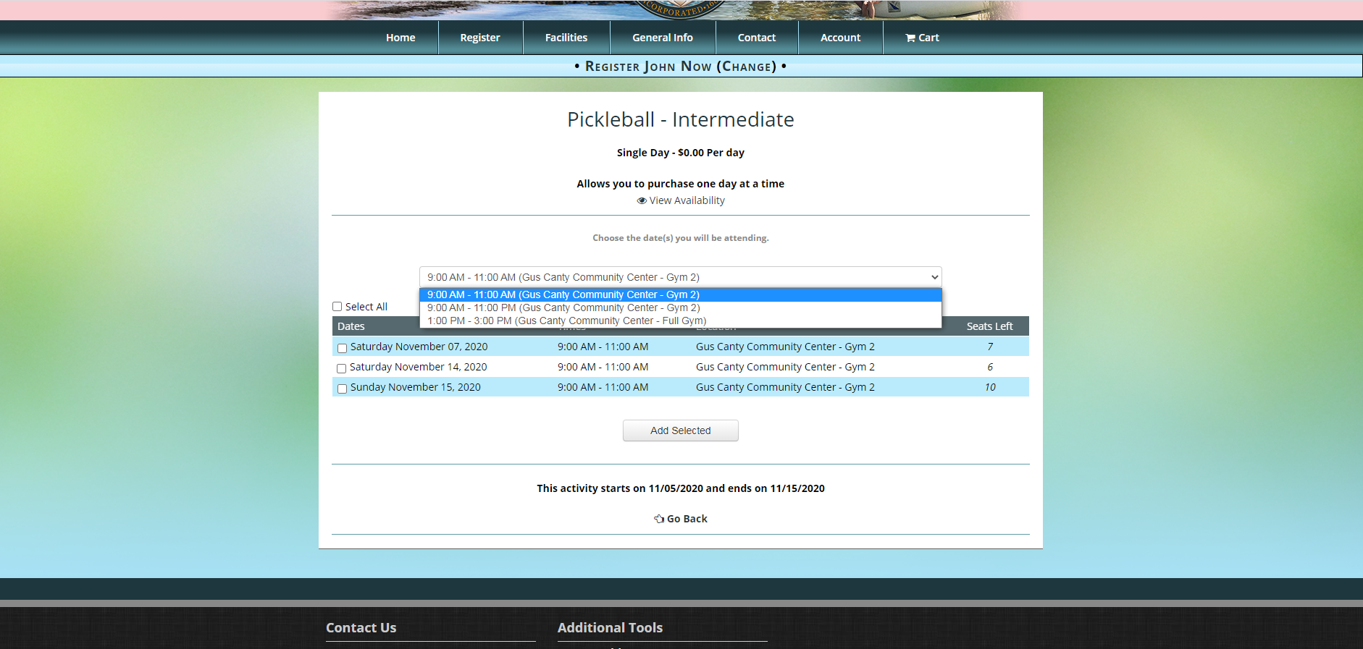

Step 7: The Selected dates will group together- Click Continue 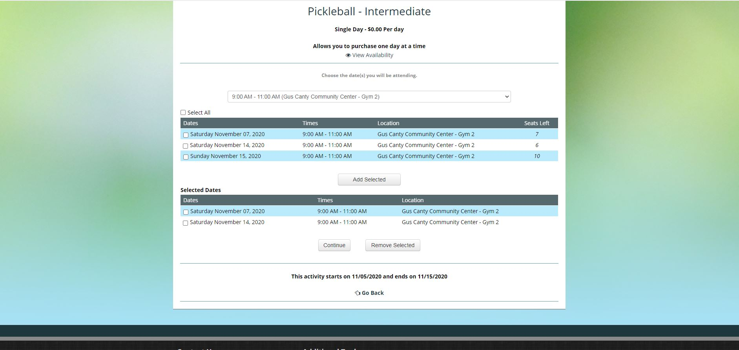

Step 8: Click Check out
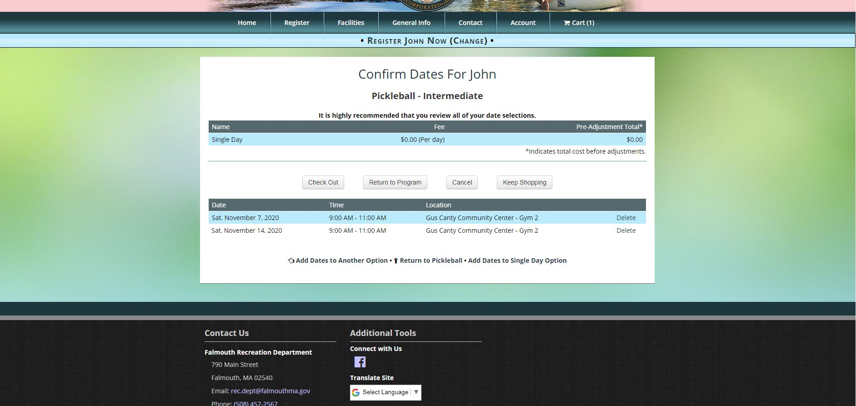

Step 9: Check off that you acknowledge the terms and conditions
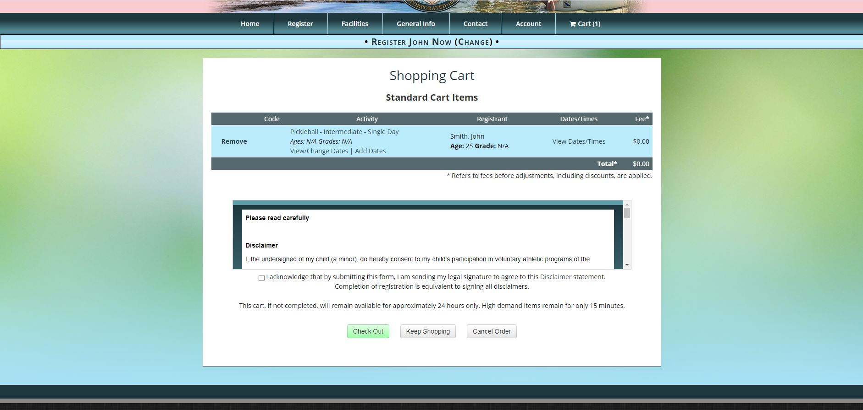
Step 10: Click Check out Online
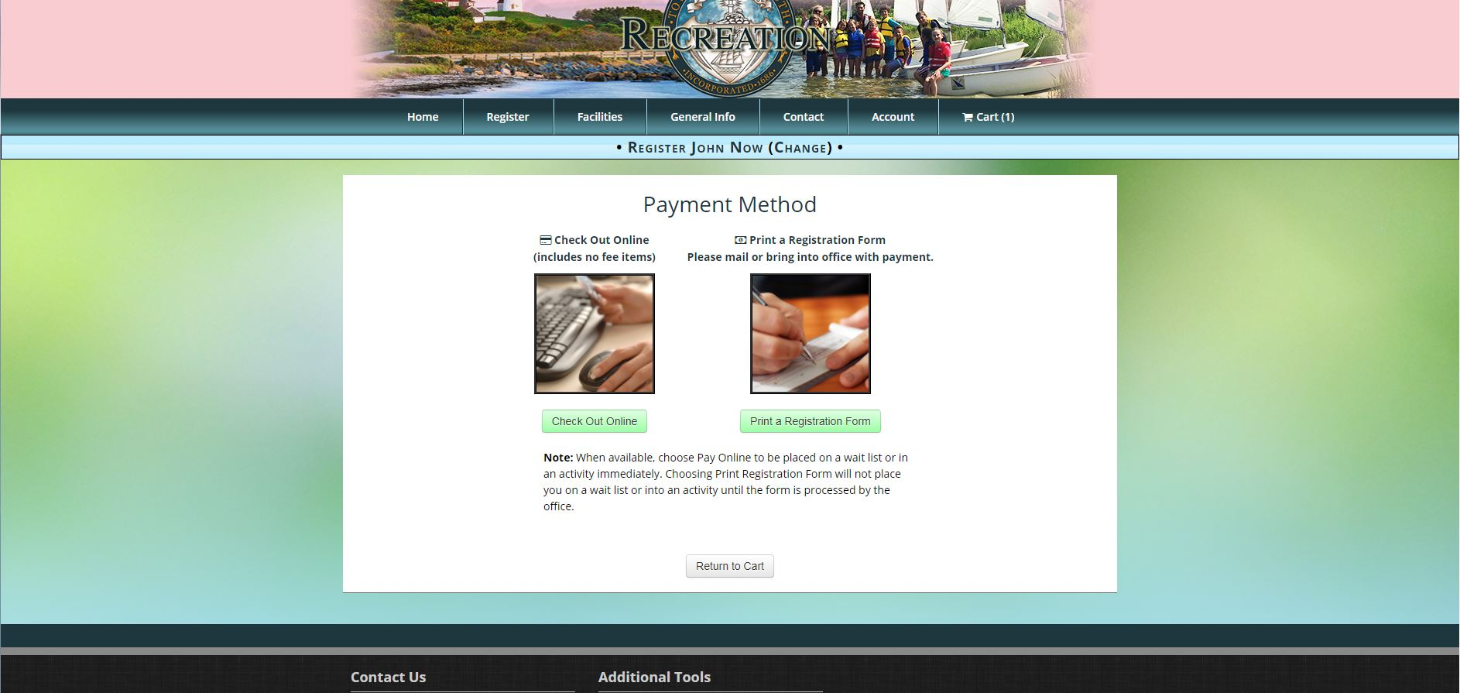

Step 11: Click Process
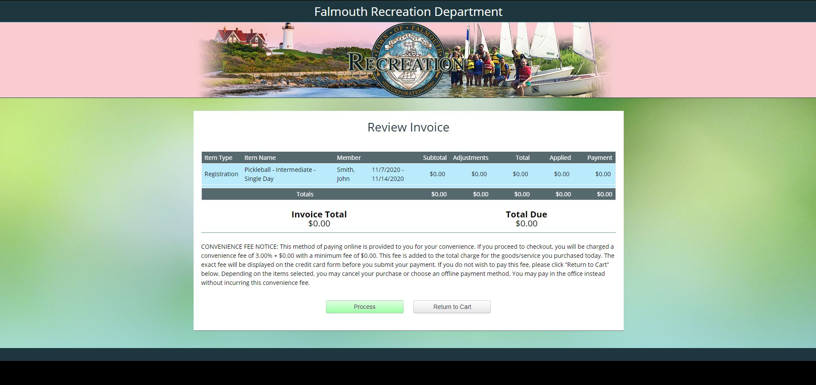
Step: 12: A confirmation of your Registration should appear as pictured below.
